 CURRICULUM VITAE

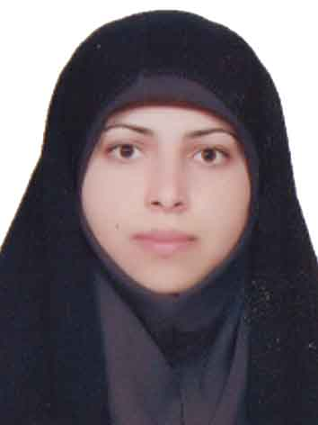**ture**

**2021**

* + **Personal Background:**

***Name:*** **Elham Shiri**

***Date of Birth: 1993***

***Nationality: Iranian***

***Marital Status:*** ***Married***

***Address: Department of Anatomy. Faculty of Medicine. Hamadan University of Medical Sciences (HUMS). Hamadan, Iran.***

***Tel/Fax: 0098-811-8380208***

***E-mail:*** e.shiri@umsha.ac.ir

* + **Current Position:**

Assistant Professor of Anatomical Sciences

* + **Education:**
  + Ph.D., in Anatomical Sciences, (2017-2020), Faculty of Medicine, Tehran University of Medical Science, Tehran, Iran
  + M.Sc, in Anatomical Sciences, (2015-2017), Faculty of Medicine, Tehran University of Medical Science, Tehran, Iran
  + B.Sc, in Orthotic And Prosthetic , (2011-2015), Faculty of Rehabilitation, iran University of Medical Science, Tehran, Iran
  + **Thesis:**
  + Study of mitochondrial function in glial cells following Umbilical cord mesenchymal stem cells transplantation in Cuprizone Induced Demyelination model in C57/BL6 mice
  + Effect of equaous Origanum vulgare extract on sperm quality of normospermic men during freezing-tawing

**Activity & Teaching:**

Gross Anatomy (Head & Neck, Trunk & osteology) for Under Graduate Students

* + **Publication:**

### Papers

1. Largani SHH, Borhani-Haghighi M, Pasbakhsh P, Mahabadi VP, Nekoonam S, **Shiri E**, et al. Oligoprotective effect of metformin through the AMPK-dependent on restoration of mitochondrial hemostasis in the cuprizone-induced multiple sclerosis model. Journal of molecular histology. 2019;50(3):263-71.

2. **Shiri E**, Abolhassani F, Khosravizadeh Z, Najafi A, Khanezad M, Vazirian M, et al. Aqueous Origanum Vulgare Extract Improves the Quality of Cryopreserved Human Spermatozoa Through Its Antioxidant Effects. Biopreservation and Biobanking. 2020;18(4):329-36.

3. **Shiri E**, Pasbakhsh P, Borhani‑Haghighi M, Alizadeh Z, Nekoonam S, Mojaverrostami S, et al. Mesenchymal Stem Cells Ameliorate Cuprizone-Induced Demyelination by Targeting Oxidative Stress and Mitochondrial Dysfunction. Cellular and Molecular Neurobiology. 2020:1-15.

4. Mojaverrostami S, Pasbakhsh P, Madadi S, Nekoonam S, Zarini D, Noori L,

**Shiri E**, et al.. Calorie restriction promotes remyelination in a Cuprizone-Induced demyelination mouse model of multiple sclerosis. Metabolic Brain Disease. 2020;35(7):1211-24.

5. **Shiri E**, Madadi S. An abnormal course of the interazygos vein: a case report. Journal of Medical Case Reports. 2020;14(1):1-3.

6. Khanehzad M, Nourashrafeddin SM, Abolhassani F, Kazemzadeh S, Madadi S, **Shiri E**, et al. MicroRNA-30a-5p promotes differentiation in neonatal mouse spermatogonial stem cells (SSCs). Reproductive Biology and Endocrinology. 2021;19(1):1-14.

### Books

* Translation of Snell's Clinical Anatomy by Regions )head and neck), 10th ed, 2019
  + **Presentation:**

### Oral

### Posters

* Mitochondrial Dysfunction And Oxidative Stress In Epilepsy. **The 6th International Epilepsy Symposium. 2018, Tehran, Iran**
* Temporal Lobe Epilepsy And Mitochondrial Dysfunction. **The 6th International Epilepsy Symposium. 2018, Tehran, Iran**
* Mitochondria As A Target For Drug Therapy In Epilepsy. **The 6th International Epilepsy Symposium. 2018, Tehran, Iran**
* Astrocyte Dysfunction In Epilepsy. **The 6th International Epilepsy Symposium. 2018 , Tehran, Iran** 
  + **Awards and Honors:**
  + Rank 1 in the Master of Anatomical Sciences exam(2015)
  + second grade student in B.Sc(2015)
  + Receiving the National Elite Foundation Scholarship Award(2017)
  + Selected as the top educational student in Ibn Sina Student Festival (2019)
  + First grade student in PhD(2020)
  + Membership in the Talent Office since (2013)